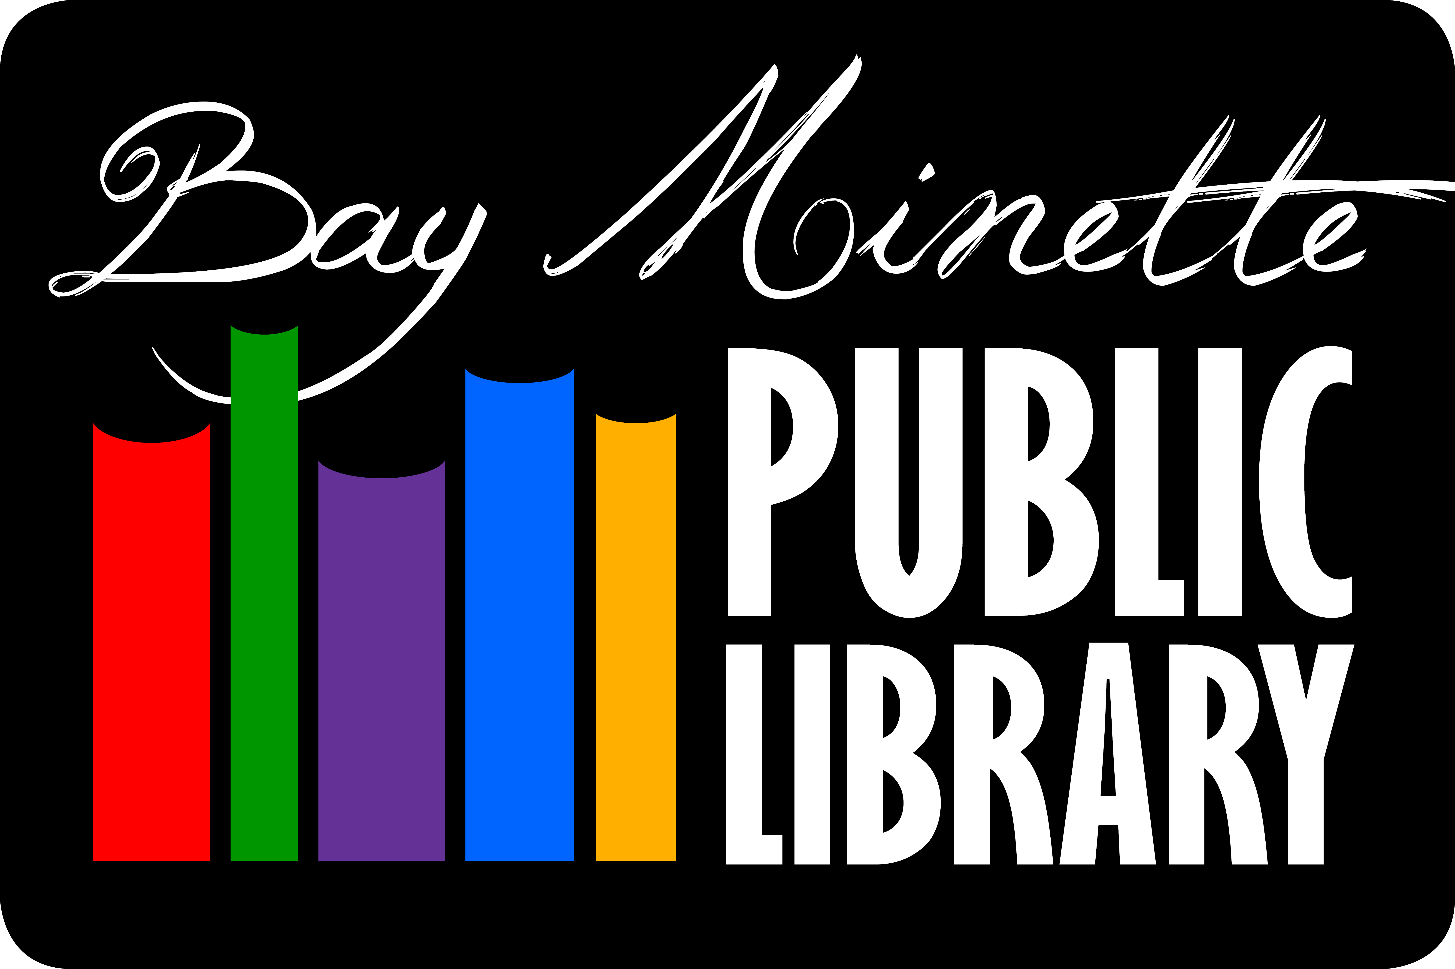

The Bay Minette
Public Library Board
2023 - 2024 Schedule
October 23, 2023
January 8th
April 8th
July 8th
October 14th
@ 5:30 p.m.
Upstairs in the
Program Room.
Posted Bay Minette Public Library, City Hall and NBU.

